1. Create a view (with name V_DEPARTMENTS) that shows all the departments with their number of employees and their town name.

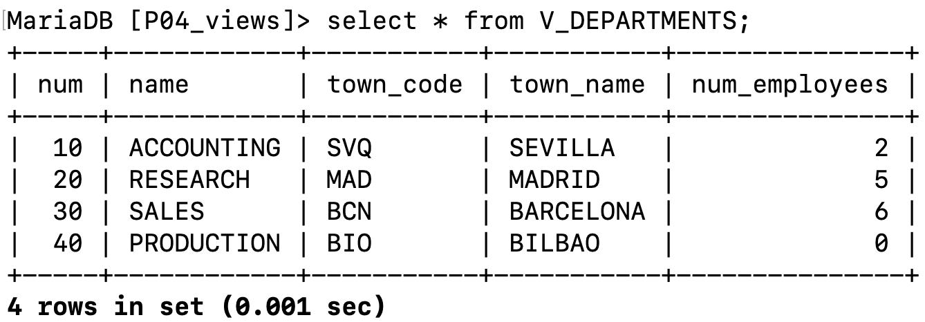

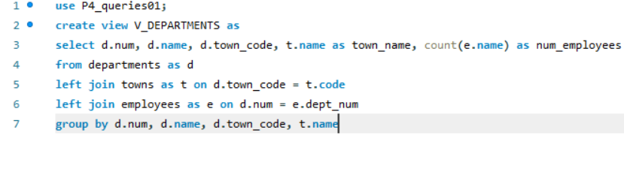

2. Update the last view to add a field with the average salary of every department. To alter a view you can check this link: <https://mariadb.com/kb/en/library/alter-view/>

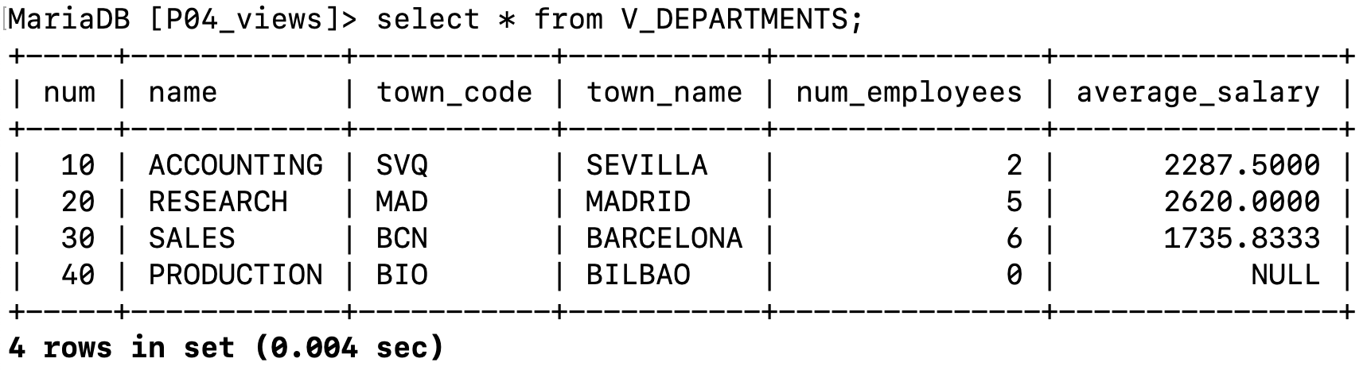

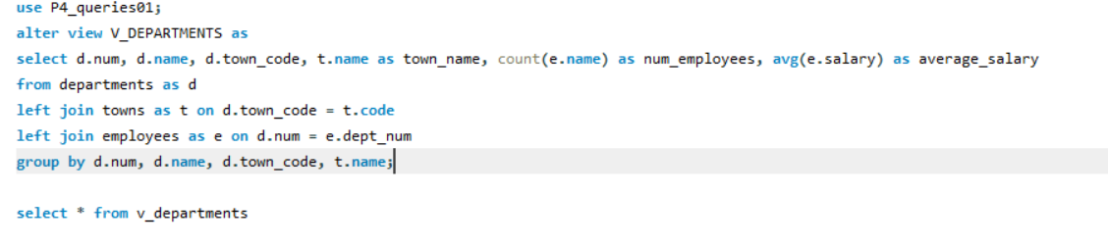

3. Insert a new departments (60 - 'HUMAN RESOURCES' - 'MAD') and a new employee with salary 9000€ who belongs to the new department (9999 - 'GONZALEZ' - 'SERGI' - NULL - '2019-01-01' - 9000 - NULL - 60 - NULL). Check if the data of the view changed automatically. Note that you must insert data into the tables EMPLOYEES and DEPARTMENTS (not into the view).

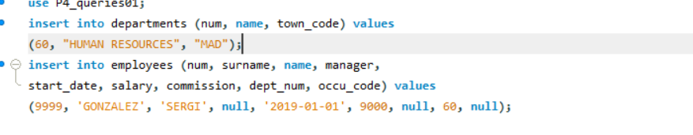

4. Create a view (with name V_EMPLOYEES) that shows all the employees with the name of their occupation instead of the occupation code and the name of their department instead of the department number.

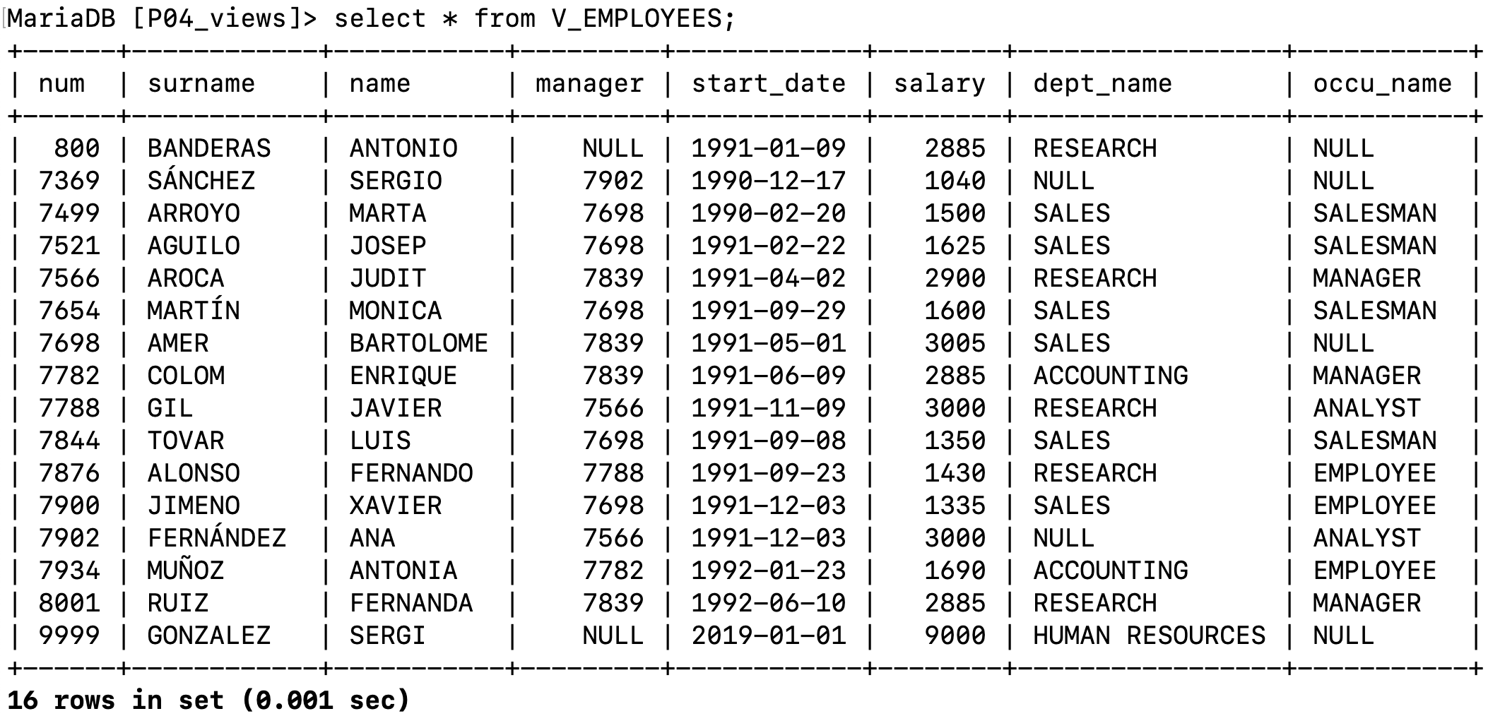

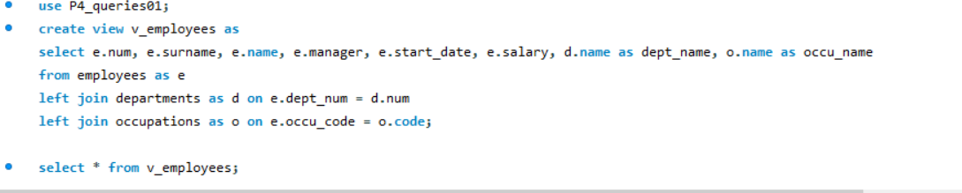

5. Create a view (with name V_EMPLOYEES_FULL) using V_EMPLOYEES that shows manager’s surname and name instead of manager num (you can NOT use the table EMPLOYEES you must use the view V_EMPLOYEES).

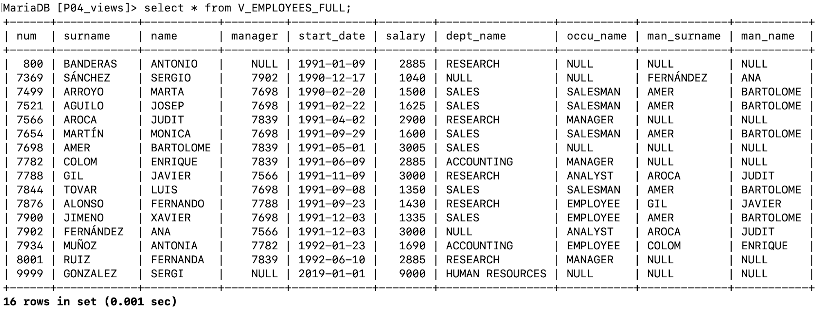

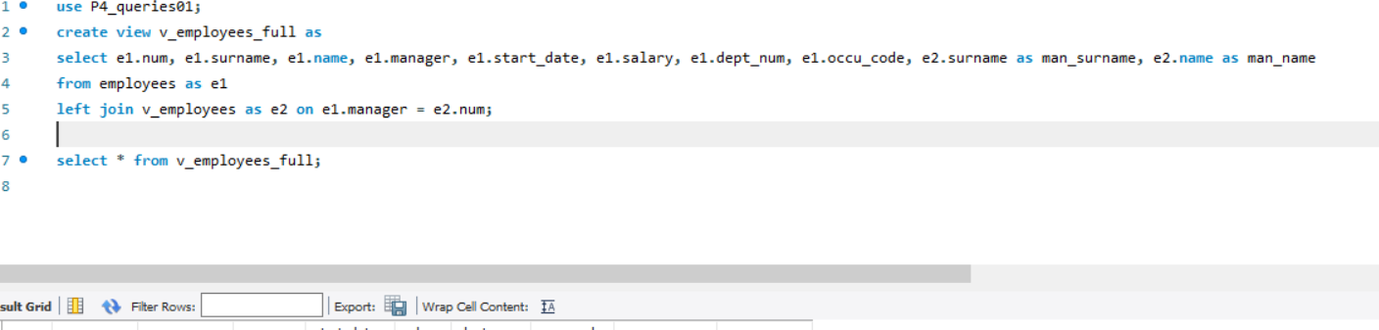

6. Try to update the EMPLOYEE with number 9999 (for instance, try to change his/her surname) using the view V_EMPLOYEES. Did it work?

7. Now insert a new employee using the view V_EMPLOYEES. Did it work? Why=

**6 y 7. No permite, porque cuando creas una vista puedes hacer querys sobre ella pero no puedes modificarla**